[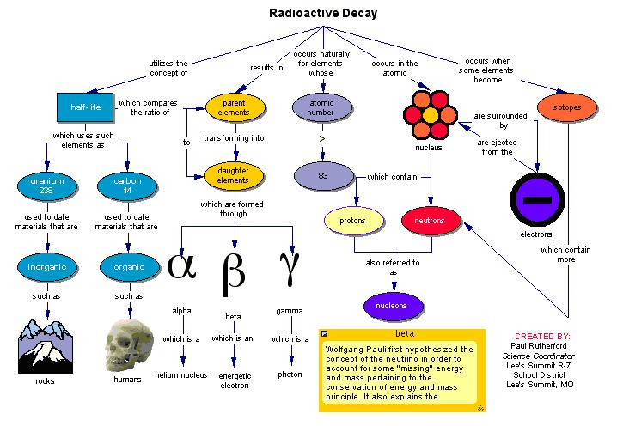](http://vignette2.wikia.nocookie.net/schools/images/0/0b/Chart.JPG/revision/latest?cb=20060611033958)